Core Java☑

✨1. JDK, JRE, and JVM (https://www.youtube.com/watch?v=gX4TEXQJaTI)
JDK stands for Java Development Kit. It contains all the necessary tools to develop Java applications, including: JRE, JVM
JRE (Java Runtime Environment): Provides the environment to run Java applications. JVM (Java Virtual Machine): The part of JRE that executes Java bytecode.
It interprets the compiled Java bytecode and executes it on any platform.
JRE, it includes the JVM, and the libraries needed to run Java applications but does not contain development tools like a compiler.
JDK provides everything needed to develop and run Java programs, while the JRE is only for running them, and the JVM is the core component that executes Java code.

✨2. OOPs concepts (https://www.youtube.com/watch?v=AEo4KgwKYoU)
OOP (Object-Oriented Programming) stands for Object-Oriented Programming language. The main purpose of OOP is to model real-world entities using programming concepts.

OOP Features:
Class: A template or blueprint for creating objects (instances).
Object: An instance of a class.
Inheritance: Allows a class to inherit properties and behaviours (methods) from another class.
Polymorphism: Polymorphism means "many forms" Poly: Many and Morphism: Forms So One Statement show multiple form is called polymorphism

Polymorphism is achieved through method overloading and method overriding:
- Method overloading: Method overloading in Java means having two or more methods (or functions) in a class with the same name and different arguments (or parameters).
Method Overloading is a feature in Java that allows a class to have multiple methods with the same name, but different parameter lists It’s always Checking at compile time, and It’s always occurs in
same class.
- Method overriding: Declaring a method in the subclass which already exists there in the parent class
The overridden method in the subclass should have the same name, return type, and parameters as the method in the superclass It’s always Checking at runtime, and It’s always occurs in super and sub class.

Encapsulation: The concept of wrapping data (variables) and methods into a single unit (class), is called Encapsulation for example Capsule
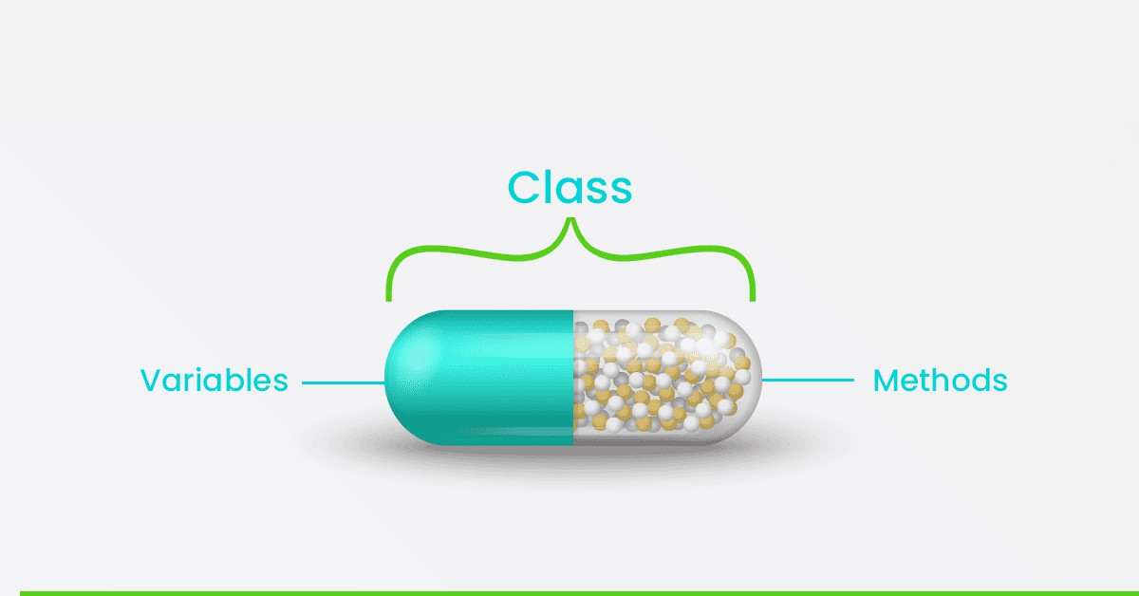
Abstraction: Hiding the complex implementation details and showing only the essential features of the object.

Abstraction in Java can be achieved in two ways:
- Using abstract classes: Abstract classes achieve partial abstraction as concrete methods can also be defined in them.
- Using interfaces: Interfaces achieve complete abstraction as only abstract methods can be defined in them.

Core-Java Note Book

- Stack vs Heap Memory: The stack is generally smaller in size than the heap because it is used for storing small, temporary variables and data, while the heap is used for storing larger objects.

- JIT Compiler: It helps to improve the performance of a Java program by compiling bytecode into native machine code at runtime.

- Java Reflection: Java Reflection is the process of modifying the behavior of a class at runtime.
Java Reflection is the process of examining and modifying the structure and behavior of a Java program at runtime.

- Double Brace Initialization: A Java technique for creating and initializing collections (like lists, sets, and maps) introduced in Java 1.2 as a feature of anonymous inner classes.
import java.util.*; class Main {

public static void main(String[] args) {
List<String> list = new ArrayList<String>() {{ add("Apple");
add("Banana");
}};
System.out.println("List: " + list);
}
}
Output: List: [Apple, Banana]

- Immutable class: Immutable class in Java means that once an object of the class is created, its state cannot be changed.
A class whose object can’t be modified after they are created String is immutable class.
A Passport is a real-life example of an immutable object once a passport is issued, It's details(Such as the passport number, date of birth, and nationality) can’t be changed. If any details needs modification, a new passport is issued.

Steps to Create an Immutable Class
  - Declare the class as final
  - Make all fields private and final
  - No setter methods
  - Initialize fields via constructor
  - Deep copy of mutable fields (if any)
  - Provide only getter methods

Simple Immutable Class Example:
public final class Person { private final String name; private final int age;
public Person(String name, int age) { this.name = name;
this.age = age;
}

public String getName() { return name; } public int getAge() { return age; }
}
class Test {
public static void main(String[] args) { Person p = new Person("Alice", 25);
System.out.println(p.getName() + " is " + p.getAge() + " years old.");
}
}

Output:
Alice is 25 years old.

Explanation:
- The Person class is final, making it immutable.
- The fields name and age are private and final.
- No setter methods are provided, ensuring the fields can't be changed after creation.
- Getter methods are used to access the values.

- Object Methods: The java. lang.Object class, the root of the Java class hierarchy, provides 11 methods.
  - clone()
  - equals(Object obj)
  - hashCode()
  - toString()
  - getClass()
  - notify()
  - notifyAll()
  - wait()
  - wait(long timeout)
  - wait(long timeout, int nanos)
  - finalize()

- Object cloning in Java refers to creating a duplicate or copy of an object. This can be done by using the clone () method, which is part of the Object class. To perform object cloning in Java, you need to implement the Cloneable interface, and then override the clone () method to create a copy of the object.

Ways of copying an object
  - Shallow Copy: Copies only the outer object, but the references to the inner objects are shared.
  - Deep Copy: Copies the entire object, including all nested objects, creating independent copies of the inner objects as well.

Key Points:
- Shallow, deep and lazy copy is related to cloning process.
- Shallow copy is faster than Deep copy.

Advance Core Java☑

✨1. String (https://www.youtube.com/watch?v=co88Om5U4bQ)
Java Strings are objects that allow us to store a sequence of characters, which may include alphanumeric values, enclosed in double quotes (e.g., "Ram2").
Important Points:
Strings in Java are immutable: Once created, their value cannot be changed.
String Methods: Java provides various methods to perform operations on strings, such as: concat (): Combines two strings.
equals (): Compares two strings for equality. length (): Returns the length of the string.
Ways to Create a String: There are two main ways to create strings in Java:
- String Literal
Strings created using string literals are stored in the String Constant Pool for memory efficiency. String a = "Ankit";
String b = "Ankit";
Here, both a and b point to the same object in the String Constant Pool.

- Using the new Keyword:
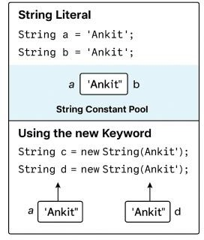
Strings created using the new keyword are stored in the Heap Memory. String c = new String("Ankit");
String d = new String("Ankit");
Each new keyword creates a new object in the heap, even if the content is the same.

Note:
String literals are stored in the String Constant Pool, which helps in saving memory.
Strings created with the new keyword are stored in Heap Memory, allowing more control but less memory efficiency.
Here’s the differences between StringBuffer and StringBuilder:

Aspect | StringBuffer | StringBuilder
Thread Safety | Synchronized and thread-safe, suitable for multithreaded environments. | Not synchronized, not thread-safe, suitable for single-threaded environments.
Performance | Slower due to synchronization overhead. | Faster as it does not have synchronization overhead.
Introduced In | Early versions of Java. | Java 5 (JDK 1.5).

✨2. Exception Handling
(https://www.youtube.com/watch?v=bxcZ7cXbDI0&list=PLqleLpAMfxGAEfyXJyF-9UOs9C8dmir_Y)
An exception is an unexpected, unwanted, or abnormal situation that occurs during the execution of a program, such as:
- ArithmeticException
- NullPointerException
- FileNotFoundException
Java provides a mechanism to handle exceptions gracefully using Exception Handling techniques,
which include using alternate sources or predefined methods to continue program execution without interruption.
Key Exception Handling Techniques
  - try: Code block where potential errors are anticipated.
  - catch: Handles exceptions thrown by the try block.
  - throw: Used to explicitly throw an exception.

  - throws: Declares that a method can throw exceptions.
  - finally: Executes code regardless of whether an exception occurs. Exception Hierarchy
    - Throwable: Root class of Java exception hierarchy.
      - Exception: Represents recoverable exceptions (e.g., IOException, RuntimeException).
      - Error: Represents critical errors that are not usually recoverable (e.g., StackOverflowError, OutOfMemoryError).
Common Exceptions:
    - RuntimeException:
      - ArithmeticException
      - NullPointerException
      - NumberFormatException
      - IndexOutOfBoundsException
    - IOException:
      - EOFException
      - FileNotFoundException try and catch Blocks
    - try block: Contains code that might throw an exception.
    - catch block: Catches and handles the exceptions thrown by the try block. Example:
public class ExceptionExample {
public static void main (String [] args) { try {
int division = 10 / 0;
} catch (ArithmeticException e) {
System.out.println("Division by zero is not allowed.");
}
}
}
Output:
Division by zero is not allowed.

Multiple try-catch Blocks
You can use multiple catch blocks to handle different exceptions. Nested try Blocks
A try block inside another try block is called a nested try block. Checked vs Unchecked Exceptions
    - Checked Exceptions: Checked by the compiler (e.g., IOException). Must be handled in the code.
    - Unchecked Exceptions: Not checked by the compiler (e.g., NullPointerException). Handled at runtime by the JVM.
Example:
try {
// risky code
} catch (IOException e) {
// handle IOException
} catch (NullPointerException e) {
// handle NullPointerException
}
throw vs throws
    - throw: Used to explicitly throw an exception. throw new ArithmeticException ("Division by zero");
    - throws: Declares that a method may throw exceptions. public void readFile () throws IOException {
// code that might throw IOException
}
finally Block
    - The finally block always executes, regardless of whether an exception occurs or not. It is used for cleanup code.
Example:
try {
System.out.println("Try block executed.");
} catch (Exception e) {

System.out.println("Catch block executed.");
} finally {
System.out.println("Finally block executed.");
}
Output:
Try block executed.
Finally block executed.
User-Defined (Custom) Exception in Java
In Java, user-defined exceptions (or custom exceptions) are exceptions that are created by the programmer to represent specific error conditions that the standard Java exceptions do not cover. This allows developers to handle application-specific scenarios in a more meaningful way.
Example: -
package user_define;
class InvalidAgeEcveption extends Exception { InvalidAgeEcveption (String msg) {
System.out.println(msg);
}
}
public class test {
public static void main (String [] args) { try {
vote (20);
} catch (Exception e) {
System.out.println(e);
}
}
public static void vote (int age) throws InvalidAgeEcveption { if (age < 18) {
throw new InvalidAgeEcveption ("Not eligible for voting");
} else {

System.out.println("Eligible for voting");
}
}
}
Difference between final finally and finalize () in java

Feature | final | finally | finalize ()
Type | Keyword | Block of code | Method
Purpose | Prevents modification or inheritance | Ensures execution of cleanup code | Cleanup before garbage collection
Usage | Variables, methods, classes | Exception handling (try- catch-finally) | Method called by the garbage collector
Example | final int x = 10; | finally {/* cleanup code */} | protected void finalize () {}

Exception Propagation
    - Exception Propagation: The process by which an exception is passed up the method call stack until it is caught.
Example:
package exception_propagation; public class Demo {
public static void main (String [] args) { try {
m1();
} catch (Exception e) {
System.out.println("Exception Handled by main method!");
}
}
public static void m1() { m2();
}
public static void m2() {

System.out.println(10 / 0);
}
}
Differences Between Exception and Error:

Exception | Error
Caused by program code. | Caused by system issues.
Recoverable. | Not recoverable.
Checked or unchecked type. | Only unchecked type.
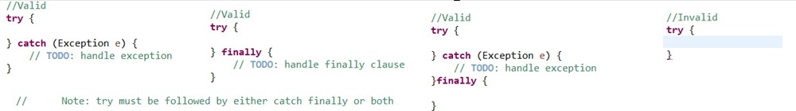

🎯3. Static and non-static blocks (IIB)
static block(https://www.youtube.com/watch?v=MuTmNsGKGDE)
A static block in Java is a block of code that gets executed once when the class is loaded into the JVM memory. It is used to initialize static variables or perform any setup needed before creating objects of the class. The static block executes before the constructor and before the instance block.

Key Points:
- A static block is executed only once, when the class is loaded into memory.
- It is executed before any instance blocks and constructors.
- It can be used for static initializations like setting up configuration data or initializing static variables.

Syntax:
static {
// Code to execute
}

Example 1:
public class A {

// Constructor A () {
System.out.println("Constructor");
}
// Instance block
{
System.out.println("Instance block");
}
// Static block static {
System.out.println("Static block");
}
public static void main (String [] args) {
System.out.println("Main method started"); A a = new A (); // Creating an object of class A
}
}

Output:
Static block
Main method started Instance block Constructor

Explanation:
- The static block executes first when the class is loaded into memory.
- The main method starts execution after the static block.
- When an object of class A is created, the instance block is executed before the constructor.

Example 2: Static Block without Object Creation
java
Copy code public class A {

// Constructor A () {
System.out.println("Constructor");
}
// Instance block
{
System.out.println("Instance block");
}
// Static block static {
System.out.println("Static block");
}
public static void main (String [] args) {
System.out.println("Main method started");
// No object of class A is created here
}
}

Output:
Static block
Main method started

Explanation:
- The static block is executed when the class is loaded, even if no object of the class is created.
- The instance block and constructor are not executed because no object of class A was created.

Non-Static Block (https://www.youtube.com/watch?v=oCtNZtP-6zk)
An instance block, also known as an instance initializer block, is a block of code written inside a class but outside any method or constructor. It is used for initializing instance variables and is executed
every time an object of the class is created.

Key Points:
- Instance blocks do not have a name and are written directly inside the class.

- They are executed before the constructor and after any static blocks (if present).
- Instance blocks are commonly used to initialize instance variables or for code that needs to be executed every time an object is created.
- You can access instance variables directly inside an instance block.
- Instance blocks cannot be declared inside methods, only inside a class.

Example: Basic Instance Block
public class Demo {
// Instance variable int value;
// Instance block
{
value = 10;
System.out.println("Inside Instance Block: Value is set to " + value);
}
// Constructor Demo () {
System.out.println("Inside Constructor");
}
public static void main (String [] args) {
System.out.println("Main method started"); Demo obj = new Demo ();
}
}

✨4. Functional Interfaces
A functional interface in Java is an interface that contains only one abstract method. It can have multiple default and static methods, but it must have only one abstract method. Functional
interfaces are used primarily in lambda expressions, method references, and streams API introduced in Java 8.
Example: Runnable, Iterator and Comparator

Key Points:

- A functional interface has exactly one abstract method.
- They can contain any number of default and static methods.
- They are marked with the @FunctionalInterface annotation (optional but recommended). This annotation indicates that the interface is intended to be a functional interface and will generate a compiler error if it does not adhere to the functional interface contract.

Common Functional Interfaces:
Java provides many built-in functional interfaces in the java. util. function package, such as:

Type of Functional Interface
  - Runnable: void run ()
  - Supplier<T>: T get ()
  - Consumer<T>: void accept (T t)
  - Predicate<T>: boolean test (T t)
  - Function<T, R>: R apply (T t)

5. Common Function Interface in java
- Function: - It will transform a stream into another Stream. Example – Such as filter, Map, flatMap, distinct, sort, limit.
- Consumer: - It will take a value& return nothing. Basically, using for logging, printing, saving.
- Supplier: - It provide a result without input.
Example – Lazy value generation (e.g. random number, config values)
Supplier<double> randomSupplier = ()->Math. Random ();
System.out.println(randomSupplier.get ());
- Predicate: - It will return true or false basically Checking Condition. Example – Filtering data in stream or collection.

✨ 6. What are Lambda Expressions
Lambda Expressions were introduced in Java 8. A Lambda Expression is a short block of code that takes in parameters and returns a value.
Lambda expressions are similar to methods, but they do not need a name and can be implemented directly in the body of a method.
A lambda Expression is an anonymous function, A function that does not have a name and does not belong to any classes

✨7. Anonymous Class
Java anonymous inner class is an inner class without a name and for which only a single object is created.
Java Anonymous inner class can be created in two ways:
  - Class (may be abstract or concrete).
  - Interface

Why Use Anonymous Classes?
    - Quick Customization: You can quickly override methods of a class or implement an interface without creating a separate subclass.
    - Concise Code: Anonymous classes can make the code shorter and more readable when only a small amount of customization is required.
    - One-Time Use: Ideal when you need a class only once, and it does not require reuse.

Syntax
The syntax of an anonymous class is as follows: new ClassName () {
// Body of the anonymous class
};
If it implements an interface:
new InterfaceName () {
// Implementation of methods
};

Example 1: Anonymous Class Extending a Class
In this example, we have a Person class with a display () method. We override the display () method using an anonymous class.
class Person { void display () {
System.out.println("Hello from Person class");
}
}
public class Main {

public static void main (String [] args) { Person person = new Person () {
@Override void display () {
System.out.println("Hello from Anonymous Class");
}
};
person. display (); // Output: Hello from Anonymous Class
}
}

Explanation:
    - Here, we create an anonymous subclass of Person and override the display () method.

Example 2: Anonymous Class Implementing an Interface
Let's consider an interface Animal with a method makeSound (). We use an anonymous class to implement this interface.
interface Animal { void makeSound ();
}
public class Main {
public static void main (String [] args) { Animal dog = new Animal () {
@Override
public void makeSound () {
System.out.println("Woof! Woof!");
}
};
dog. makeSound (); // Output: Woof! Woof!
}
}

Summary

    - Anonymous classes are useful for quick, one-time-use customizations.
    - They are concise and allow inline implementation of methods, making the code more readable for small tasks.
    - However, they should be used with caution, as they can reduce code readability if overused or in complex scenarios.

✨8. Enums
An enum is a special "class" that represents a group of constants (unchangeable variables, like final variables).
To create an enum, use the enum keyword (instead of class or interface), and separate the constants with a comma. Note that they should be in uppercase letters:
Enum is short for "enumerations", which means "specifically listed".

Key Features of Enums in Java
- An enum can, just like a class, have attributes and methods.
- The only difference is that enum constants are public, static and final (unchangeable - cannot be overridden).
- An enum cannot be used to create objects, and it cannot extend other classes (but it can implement interfaces).
- Enum, introduced in Java 5 Example:
enum Day {
SUNDAY, MONDAY, TUESDAY, WEDNESDAY, THURSDAY, FRIDAY, SATURDAY
}
public class Main {
public static void main (String [] args) { Day today = Day. MONDAY;
System.out.println("Today is: " + today);

if (today == Day. MONDAY) {
System.out.println("Start of the work week!");
}
}
}

Output:
Today is: MONDAY
Start of the work week!

✨9. Java Stream API (map, filter, and forEach)
Java 8 introduced the Stream API, which provides a powerful way to work with sequences of data
using a functional programming approach. The map, filter, and forEach methods are commonly used Stream operations.

map Method
The map method is used to transform elements of a Stream. It applies a given function to each element of the Stream and returns a new Stream with the transformed elements.

Key Points:
  - It takes a function as an argument and applies it to each element.
  - It returns a new Stream where each element is the result of the applied function.
  - It is an intermediate operation, meaning it does not trigger the processing until a terminal operation like collect () or forEach () is called.

filter Method
The filter method is used to select elements based on a given condition. It tests each element using a
predicate (boolean function) and includes only the elements that match the condition.

Key Points:
  - It takes a predicate (a function returning a boolean value).
  - It returns a new Stream containing only the elements that satisfy the condition.
  - It is also an intermediate operation.

forEach Method
The forEach method is a terminal operation that is used to iterate over each element of a Stream and perform an action.

Key Points:
  - It takes a Consumer (a function that performs an action on each element).
  - It does not return a value (returns void).
  - It is typically used for printing or performing side effects.

Combined Example: map, filter, and forEach
import java. util. Arrays;

import java. util. List;
public class StreamAPIExample {
public static void main (String [] args) {
List<String> names = Arrays.asList("Alice", "Bob", "Alexander", "Charlie");
// Using map, filter, and forEach together names. stream ()
. filter (name -> name. length () > 3) // Filter names with more than 3 characters
. map(String::toUpperCase) // Convert to uppercase
. forEach (System. Out::println); // Print each name
}
}
Output:
ALICE
ALEXANDER CHARLIE

Key Takeaways:
  - The Stream API is a powerful tool for processing sequences of elements in a functional style.
  - The map method transforms elements.
  - The filter method selects elements based on a condition.
  - The forEach method performs an action on each element.

Ways to Create a Stream Object in Java

Method | Description
Stream. Of () | Creates a Stream from specified values.
Collection. Stream () | Creates a Stream from a Collection (List, Set).
Arrays. Stream () | Creates a Stream from an array.
Stream.builder() | Creates a Stream using a builder.
Stream.generate() | Creates an infinite Stream from a Supplier.
Stream.iterate() | Creates an infinite Stream by applying a function repeatedly.

✨10. Properties Class
The Properties class in Java is part of the java. util package. It is a subclass of Hashtable and is used to store key-value pairs where both the key and the value are strings. The Properties class is often used for configuration settings, storing user preferences, or loading application properties from a file.

Key Features of Properties Class
- Extends Hashtable: It inherits from the Hashtable class, so it can use all methods of a Hashtable (e.g., put (), get ()).
- String Key-Value Pairs: It only stores data as key-value pairs of strings.
- Configuration Files: It is commonly used for reading from and writing to. properties files (text files containing key-value pairs).
- Convenience Methods: It provides methods like load (), store (), getProperty (), and setProperty () for easy access to properties.

Example 1: Basic Usage of Properties Class
import java.util. Properties; public class PropertiesExample {
public static void main (String [] args) {
// Creating a properties object
Properties properties = new Properties ();

// Setting properties using setProperty () properties. SetProperty ("username", "admin"); properties. SetProperty ("password", "12345");
properties. SetProperty ("url", "https://example.com");

// Retrieving properties using getProperty ()
String username = properties. getProperty("username"); String password = properties. getProperty("password"); String url = properties. getProperty("url");

// Printing the properties

System.out.println("Username: " + username); System.out.println("Password: " + password); System.out.println("URL: " + url);
}
}
Output:
Username: admin Password: secret
URL: https://mywebsite.com

Key Methods of Properties Class

Method | Description
setProperty (String key, String value) | Sets the property key-value pair.
getProperty (String key) | Returns the value for the specified key.
getProperty (String key, String defaultValue) | Returns the value for the key or the default value if the key is not found.
load (InputStream inStream) | Loads properties from an input stream (e.g., file).
store (OutputStream out, String comments) | Writes properties to an output stream (e.g., file) with optional comments.
list (PrintStream out) | Prints all properties to the specified output stream.
containsKey (Object key) | Checks if the specified key exists.

✨11. HTTP Vs HTTPs:
HTTP Vs HTTPs are protocols that are used in web to transfer data. HTTPs is more secure since it is Encrypted and authenticated.
The HTTP protocol provides Communication between different communication System HTTP 1. It uses port 80 by default. 2. HTTP URLs Begin with http://
HTTPs 1. It was using port 443 by default. 2. HTTPs URLs begin with https://

Mobile – Image

✨ 1. Final, Finally & Finalize

Keyword | Type | Usage
final | Keyword | We are Using for restrict modification of variables, methods, or classes.  - final class – cannot be extended  - final method – cannot be overridden  - final variable – cannot be re-initialized
finally | Block | We are using for cleanup code. It is associated with try-catch blocks and always executes after the try or catch.
finalize () | Method | Finalized method is called by garbage collector just before destroying an object.

✨ 2. String vs StringBuffer Vs StringBuilder
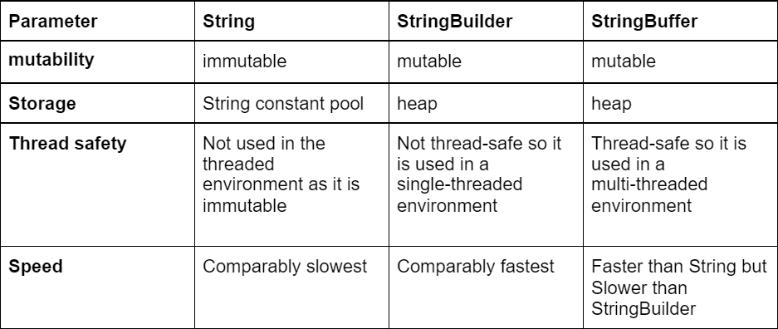

✨ 3. ==Operator vs. equals ()
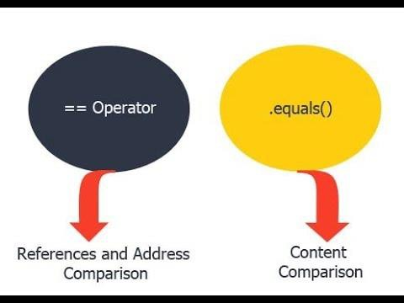

Frequently Asked Questions☑

✨1. What do you mean by wrapper class?
In Java, a wrapper class is a class that converts primitive data types into objects:
Explanation: Primitive data types like byte, short, int, long, float, double, char, and boolean are not objects.
For example, the wrapper class for the primitive data type int is Integer.
Boxing - Converting Primitive Type - Object
Unboxing - Converting Object into Primitive Type
Autoboxing - Is a java Feature that Automatically Convert Primitive data types to their corresponding wrapper class object//int->Integer

✨2. Serialization and Deserialization
In Java, serialization and deserialization are processes that convert an object's state into a byte stream and back again:
Serialization: Converts an object's state into a byte stream, which can be stored in a file, database, or sent over a network.
Deserialization: Converts the byte stream back into an object with its original state.

✨3. Key Java 8 Features Functional Programming Features Lambda Expressions
Method References Functional Interfaces Stream API
Stream API: - Operation are classified into two types.
Intermediate Operations: (It will Transform a stream into another Stream) Operations that transform or filter a stream, such as filter, map, flatMap, distinct, sorted, and limit.
Terminal Operations: (It Will Produce a result or side-effect) Operations that produce a result or side effect, such as forEach, collect, reduce, anyMatch, allMatch, and findFirst.
Date and Time API

Java Time API:

Other Notable Features
Default and Static Methods in Interfaces: Allow interfaces to have method implementations, making it easier to add new functionality to existing interfaces.
Optional Class: A container object that may or may not contain a non-null value, helping to avoid NullPointerException.
forEach () Method:
Base64 Encoding and Decoding:
Nashorn JavaScript Engine: A high-performance JavaScript engine embedded in the JVM. Parallel Array Sorting: Improved performance for sorting large arrays.

✨4. Marker interface in Java
A marker interface in Java is an empty interface with no fields or methods, used to indicate that a class has a specific property or capability.
- A Marker interface is an interface without any methods
- Also called as Tag interface e.g., Serializable, Cloneable
The purpose of marker interface is to group multiple classes into a common category
- The wrapper class objects, String objects can be serialized as these classes implement Serializable
WhatsApp group - like marker interface - to group people from different lifestyles into a common category
e.g., school group, office group
Here's an example using the Serializable interface:
import java.io. Serializable;
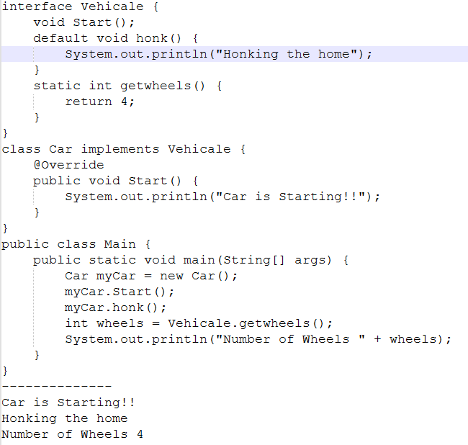
class Employee implements Serializable { String name;
int id;
public Employee (String name, int id) { this.name = name;
this.id = id;
}

}
Note: For Making Marer Interface class your class have to implements serializable. In this example:
- Serializable: is a marker interface. It doesn't declare any methods, but it signifies that the implementing class (Employee) can be serialized.
- Serialization: is the process of converting an object into a byte stream, which can be saved to a file or transmitted over a network.
- By implementing Serializable, the Employee class indicates that its objects can be serialized. This allows you to store the object's state and later reconstruct it.

Static blocks and constructors
In Java, static blocks are used to initialize static variables, while non-static blocks are used to initialize variables declared in the class
In Java, a constructor is a special method used to initialize objects and create instances of classes.

Java Reflection
Java Reflection is a process of examining or modifying the run time behavior of a class at run time.
In Java, reflection allows us to inspect and manipulate classes, interfaces, constructors, methods, and fields at run time.
Reflection is a feature which allow to modify the behaviour of method,
Classes and interfaces in java so there are many methods like Get class, get method and get constructor
Due to which we can you know modify the behaviour And write our code accordingly
So, it's just like a future to make some changes like that

Functional interface
A functional interface cannot extend an interface that has an abstract method because it would violate the rule that a functional interface only allows one abstract method.
Only one abstract method in that class is known as functional like interface
Example: Runnable and comparator

✨8. About Singleton?
Singleton is a design pattern that ensures a class has only one object in entire Application. singleton class is a class whose only one instance can be created at any given time, in one jvm. A class can be mode Singleton by making its constructor as private.

Steps to Implement Singleton Pattern
  - Make the constructor private to restrict initialization from outside the class.
  - Create a static variable to hold the single instance of the class.
  - Provide a public static method to access the instance.
  - We can write getMethod not setMethod.
Note: Also, Anonymous which only single object is created.

Example of Singleton Pattern in Java with Eager Initialization
public class Singleton {
private static Singleton instance; private Singleton () {}
private static Singleton getInstance () { if (instance == null) {
instance = new Singleton ();
}
return instance;
}
public void getConnection () {
System.out.println("You are now connected to the database.");
}
public static void main (String [] args) {
Singleton db = Singleton.getInstance(); db. getConnection ();
}
}
OUTPUT: You are now connected to the database.

NOTE-BOOK

1. Local Variable Vs Instance Variable
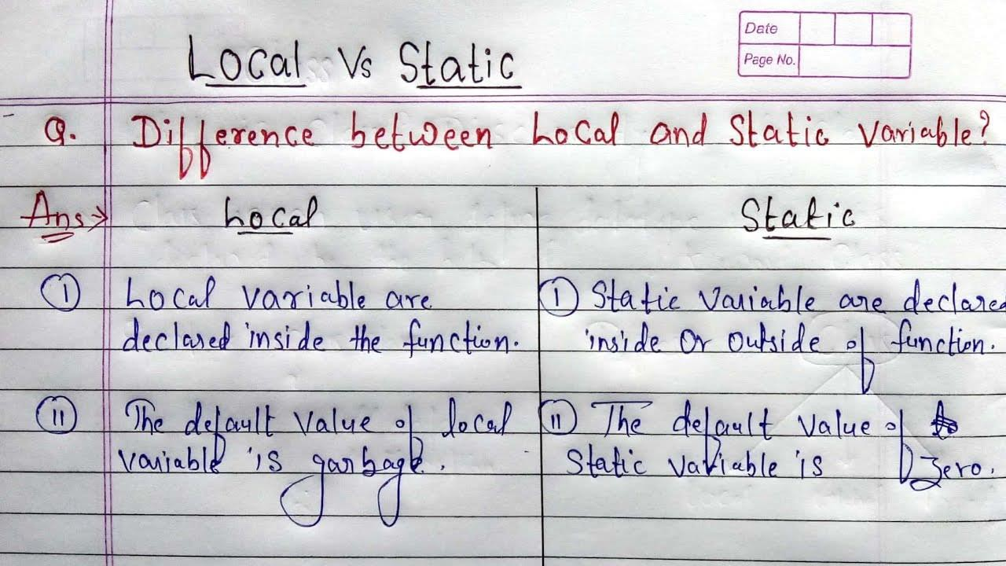
public class Example {
int instanceVariable = 20; // Instance variable void method () {
System.out.println(instanceVariable);
}
}
public class Example { void method () {
int localVariable = 10; // Local variable System.out.println(localVariable);
}
}

  - Classloader: Responsible for loading .class files into the JVM when the program runs

OOP’s

- Polymorphism: Polymorphism means "many forms" Poly: Many and Morphism: Forms So One Statement show multiple form is called polymorphism

Runtime Polymorphism or Dynamic Method Dispatch
  - Method overloading: Method overloading in Java means having two or more methods (or functions) in a class with the same name and different arguments (or parameters).
Method Overloading is a feature in Java that allows a class to have multiple methods with the same name, but different parameter lists It’s always Checking at compile time, and It’s always occurring in same class.
  - Method overriding: Declaring a method in the subclass which already exists there in the parent class
The overridden method in the subclass should have the same name, return type, and parameters as the method in the superclass It’s always Checking at runtime, and It’s always occurring in super and sub class.

Different Type of Interface
Types of Interfaces
- Functional Interface
- Marker interface
- Functional Interface:
  - Functional Interface is an interface that has only pure one abstract method.
  - It can have any number of static and default methods and also even public methods of java. lang. Object classes
When an interface contains only one abstract method, then it is known as a Functional Interface. Examples of Functional Interfaces:
  - Runnable: It contains only run () method
  - ActionListener: It contains only action Performed ()
  - ItemListener: It contains only itemStateChanged () method

- Marker Interface:
  - An interface that does not contain any methods, fields, Abstract Methods, and any Constants is Called a Marker interface.
  - Also, if an interface is empty, then it is known as Marker Interface.
  - The Serializable and the Cloneable interfaces are examples of Marker interfaces.

What is multiple interface? It’s Supported by Java.
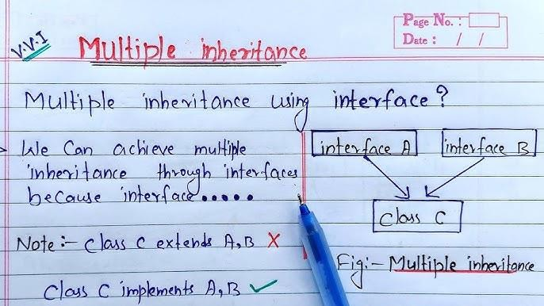

- Association is a relationship between two classes using their object types. The types of association are:
- One-to-one
- One-to-many
- Many-to-one
- Many-to-many
- Aggregation is a 'Has-A' relationship, which is a one-way relationship between two objects. For example:
  - A student has an address (A student can have an address).
  - A car object has an engine object, wheels object, and doors object.

- Composition: Composition in Java is a design technique that establishes a "has-a" relationship between classes.

Collection

- Define What is Collection & about Framework
Collection is Farmwork /Interface.
A Farmwork is a set of classes and interface which provide a ready-made architecture.
Collection Farmwork is a grouping of classes and interface that is used to store and mange the object. It provides Various class Like Vector, ArrayList, hashSet, Stack, etc.
Java Collection is Farmwork can also be used for interface like Queue, Set, List etc.

Iterator Vs ListIterator

Iterator | ListIterator
It Can be used in Queue, List and Set | It Can be used list only
It Can Perform Only Remove operation | It Can Perform add, remove and set operation while traversing the collection
Iterator can Traverse only in forward direction | ListIterator Traverses both in forward and backword direction.  Forword direction- hasNext (), Next (), nextIndex ()  Backword Direction- previous (), hasPervious (), previousIndex (), Remove ()

- Iterator Vs Enumeration

Iterator | Enumeration
Iterator does have remove () method. | Enumeration does not have remove () method.
The Iterator is very slow compare to Enumeration | Enumeration is fast compare to Iterator.
The Iterator is fail fast (Immediately throw concurrentmodification exception if there is Structural modification of the Collection.) | Enumeration is not fail fast.
Method Name 1. next (), remove (), hasNext () | Method Name: nextElement (), 2. hahMoreElements () 3. asIterator ()

Note: Fail-fast is a programming principal that causes a system to stop working immediately when it encounters an unexpected.

Note: System to Stop Working immediately.

Comparable Vs Comparator

Comparable | Comparator
Comparable provides compareTo () method to Sort element in java | Comparator provides compare () method to sort element in java.
Comparable interface is present in java. long. package. It’s introduced 1.0v | Comparator interface is present in java. util. package. It’s Introduce 1.2v
It provides Single sorting Sequence | It provides multiple sorting sequences.

- HashMap Work Internally
✨How HashMap Works Internally in Java (https://www.youtube.com/watch?v=1CJbB6SzjVw)
What is Hashing (https://www.javatpoint.com/working-of-hashmap-in-java)
It is the process of converting an object into an integer value. The integer value helps in indexing and faster searches.
It uses a technique called Hashing. There are four fields in HashMap.
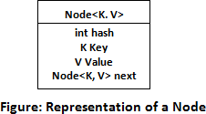

First, It's Calculating Index
Index minimizes the size of the array. The Formula for calculating the index is:
  - Index = hashcode (Key) & (n-1)
Where n is the size of the array. Hence the index value for "Aman" is:
- Index = 2657860 & (16-1) = 4
The value 4 is the computed index value where the Key and value will store in HashMap.

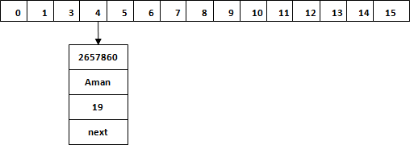

Hash Collision
This is the case when the calculated index value is the same for two or more Keys. Let's calculate the hash code for another Key "Sunny." Suppose the hash code for "Sunny" is 63281940. To store the Key in the memory, we have to calculate index by using the index formula.
- Index=63281940 & (16-1) = 4
The value 4 is the computed index value where the Key will be stored in HashMap. In this case,
equals () method checks that both Keys are equal or not. If Keys are same, replace the value with the current value. Otherwise, connect this node object to the existing node object through the LinkedList. Hence both Keys will be stored at index 4.
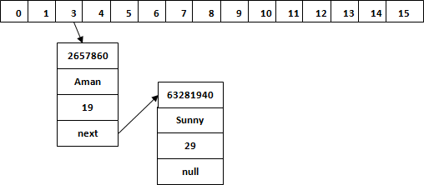

Similarly, we will store the Key "Ritesh." Suppose hash code for the Key is 2349873. The index value will be 1. Hence this Key will be stored at index 1.

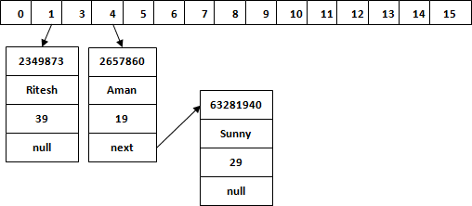

Hash Collision Step:
If I’m talking about Hash Collision so it’s occurred when the calculated index value is the same for two or more Key Index.
- It Will Check both index is same or not.
- if index is same then we have to check weather both index key is equal or not using. equal () method.
- if key is same, replace the value with the current value.
- if key is not same then it will connect node object to the exiting node object through the LinkedList.
- Hence Both keys will be stored at same index.

Collection Architecture
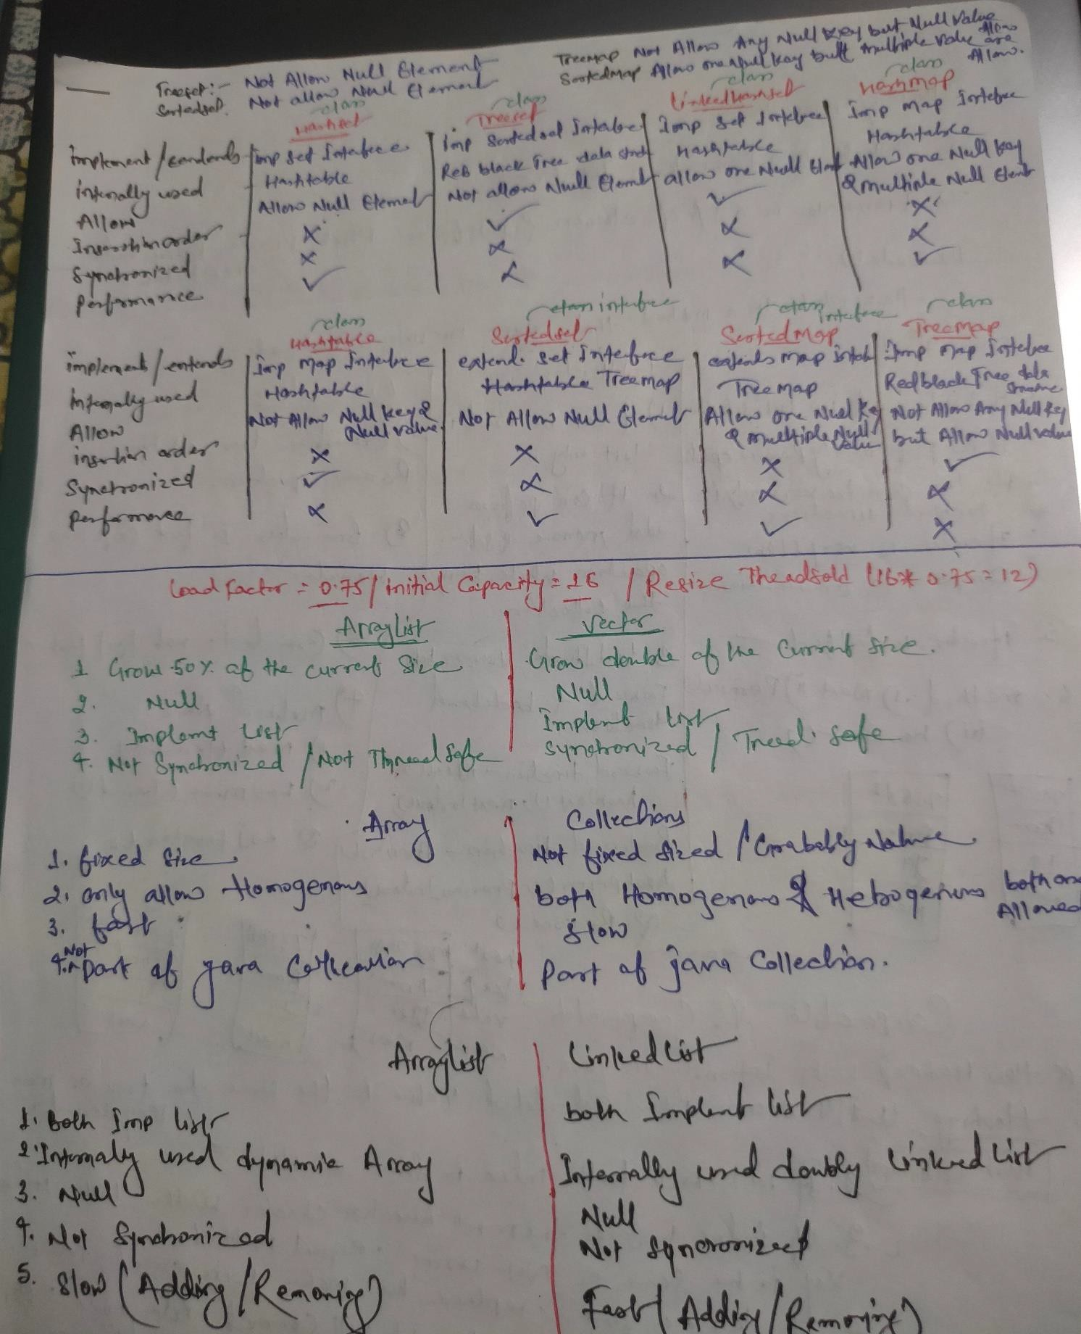

- What is a “Concrete” Method class or Interface?
Concreate – Means Something that is fully implemented//or fully Completed – It is not Abstract.
- Concreate Class: - A class that has complete code and can be used to create object. Example: -
ArrayList<String> list = new ArrayList<> ();
Note: - ArrayList is a concreate class in the java Collection Framework.
- Concreate Method: - A method that has a body (code) and does Something. Example: - Void SayHello () {
System.out.println(“Hello”);
}
Note: - This is a Concreate Method because it has Code inside.

Concrete Interface (In newer java Version)
In java 8+ Interface can have default method, which are Concreate method inside an interface. Example: -
Interface MyInterface {
default void greet () { System.out.println(“Hi”);
}
}
Note: - greet () is a concreate method in an interface.

What is a “Concreate hashMap” in java Collection?
When We Say” Concreate hashMap” We mean the hashMap Class in java Collection farmwork that is fully implemented. It’s not abstract and we can create object from it directly.
Example: -
Map<String, String> map = new hashMap<> ();
map. Put (“name”, “John”);
map. Put (“city”, “delhi”);
Here, hashMap is a concreate class that implements the Map Interface.

3. Comparable Vs Comparator

HashMap | ConcurrentHashMap
HashMap is not Synchronized | ConcurrentHashMap is Synchronized
Not Thread Safe | Thread Safe
It’s faster because at a time multiple thread is allow. | It’s Slow because at a time only one thread is allowed.
Allow Null Key & Value | Not Allow null Key & value
HashMap implement map Interface | ConcurrentHashMap implements ConcurrentMap interface.

Thread
- Threads
Multithreading in Java
Multithreading in Java allows multiple threads to run concurrently, providing the capability to
perform multiple tasks simultaneously without dependency. A thread is a lightweight process that is the smallest unit of execution.

Creating Threads in Java
In Java, there are two main ways to create a thread:
  - By extending the Thread class.
  - By implementing the Runnable interface ()
Multitasking – the running of multiple programs in one computer of the same time. Type- 1. Process – based multitasking
- Thread -based multitasking
The ability to execute multiple tasks or process simultaneously.

Example 1: Extending Thread Class
class MyThread extends Thread { public void run () {

System.out.println("Thread is running.");
}
public static void main(String[] args) { MyThread t1 = new MyThread(); t1.start(); // Starts the thread
}
}

Example 2: Implementing Runnable Interface
class MyRunnable implements Runnable { public void run() {
System.out.println("Thread is running using Runnable interface.");
}
public static void main(String[] args) {
Thread t1 = new Thread(new MyRunnable()); t1.start();
}
}

Thread Scheduler
The Thread Scheduler in Java determines which thread should run. It uses various scheduling algorithms such as:
- FIFO (First In First Out)
- SJF (Shortest Job First)
- Round Robin
The scheduling mechanism depends on the underlying operating system's implementation.

Thread Life Cycle
A thread in Java goes through several states:
- New: Thread is created but not started.
- Runnable: Thread is ready to run and waiting for CPU time.
- Running: Thread is executing.
- Waiting/Blocked: Thread is paused, waiting for some condition.

- Terminated (Dead): Thread has completed execution.

Diagram
New → Runnable → Running → Waiting → Terminated
↳ (Blocked)
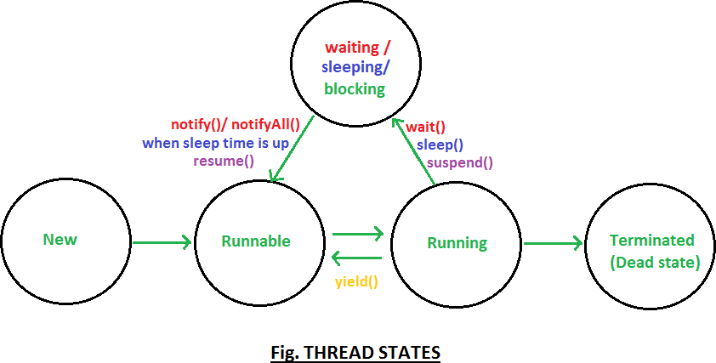

Difference Between sleep() and join()
- sleep(long milliseconds): Pauses the current thread for the specified time. Example:
public class SleepExample {
public static void main(String[] args) { try {
System.out.println("Sleeping for 2 seconds..."); Thread.sleep(2000);
System.out.println("Woke up!");
} catch (InterruptedException e) { e.printStackTrace();
}
}
}
- join(): Waits for a thread to finish its execution before the current thread resumes. which allows one thread to wait until another thread completes its execution.
Example:
class MyThread extends Thread { public void run() {
System.out.println("Child thread running...");

}
}

public class JoinExample {
public static void main(String[] args) { MyThread t1 = new MyThread(); t1.start();
try {
t1.join();
System.out.println("Main thread resumes after child thread completes.");
} catch (InterruptedException e) { e.printStackTrace();
}
}
}

suspend() and resume() Methods
- suspend(): Pauses the thread.
- resume(): Resumes the suspended thread.
Note: These methods are deprecated due to the risk of deadlocks from jdk1

yield() Method
The yield() method allows a thread to pause its execution and give a chance for other threads of the same priority to run.

Example:
class YieldExample extends Thread { public void run() {
for (int i = 0; i < 3; i++) {
System.out.println(Thread.currentThread().getName() + " yielding control..."); Thread.yield();
}
}

public static void main(String[] args) {
YieldExample t1 = new YieldExample(); YieldExample t2 = new YieldExample(); t1.start();
t2.start();
}
}

isAlive () Method
The isAlive () method checks whether a thread is still running.

Example:
class MyThread extends Thread { public void run () {
System.out.println("Thread running...");
}
public static void main(String[] args) { MyThread t1 = new MyThread();
System.out.println("Before starting, isAlive: " + t1.isAlive()); t1.start();
System.out.println("After starting, isAlive: " + t1.isAlive());
}
}

interrupt () Method
The interrupt() method interrupts a thread, especially if it is in a sleeping or waiting state.

Example:
class InterruptExample extends Thread { public void run() {
try {
Thread.sleep(1000);
System.out.println("Thread running...");
} catch (InterruptedException e) {

System.out.println("Thread interrupted.");
}
}
public static void main(String[] args) {
InterruptExample t1 = new InterruptExample(); t1.start();
t1.interrupt(); // Interrupts the thread
}
}

Thread Priority
In Java, each thread has a priority, which can be set using setPriority(int priority). The priority ranges from:
- Thread.MIN_PRIORITY (1)
- Thread.NORM_PRIORITY (5)
- Thread.MAX_PRIORITY (10)
Note: If exceed size 10- illegalargumentexception

Synchronization
Synchronization is a mechanism that ensures that only one thread can access a shared resource at a time, preventing thread interference and consistency issues.

Example of Method-Level Synchronization:
class Counter {
synchronized void printCount() { for (int i = 1; i <= 5; i++) {
System.out.println(Thread.currentThread().getName() + " Count: " + i);
}
}
}
class SyncExample extends Thread { Counter counter;

SyncExample(Counter counter) { this.counter = counter;
}
public void run() { counter.printCount();
}
public static void main(String[] args) { Counter counter = new Counter();
SyncExample t1 = new SyncExample(counter); SyncExample t2 = new SyncExample(counter);

t1.start();
t2.start();
}
}

Output:
Thread-0 Count: 1
Thread-0 Count: 2
Thread-0 Count: 3
Thread-0 Count: 4
Thread-0 Count: 5
Thread-1 Count: 1
Thread-1 Count: 2
Thread-1 Count: 3
Thread-1 Count: 4
Thread-1 Count: 5

Problem with Multithreading
Multithreading can lead to issues such as race conditions and inconsistent data when multiple threads access shared resources simultaneously without proper synchronization.
How To use Static Synchronization for resolved Problem

Example:
package static_synchronization;
class Bank extends Thread
{
static int bal =5000; static int withdraw; Bank(int withdraw)
{
this.withdraw =withdraw;
}
public static synchronized void Withdrow() {
String name = Thread.currentThread().getName();
if(withdraw<=bal)
{
System.out.println(name+" withdraw money");
bal =bal-withdraw;
}else {
System.out.println("Insufficient Balance");
}
}
public void run() {
Withdrow();
}
}
public class Customer {

public static void main(String[] args) {
// TODO Auto-generated method stub Bank obj = new Bank(5000);
Thread t1 = new Thread(obj);

Thread t2 = new Thread(obj); t1.setName("Raju");
t2.setName("Sunita");

Bank obj2 = new Bank(5000); Thread t3 = new Thread(obj2); Thread t4 = new Thread(obj2); t3.setName("Raju");
t4.setName("Sunita");

t1.start();t2.start();
t3.start();t4.start();
}

}
Output:
Raju withdraw money Insufficient Balance Insufficient Balance Insufficient Balance

2.Create Thread manually Vs using ExecutorService
- New Thread created every time when you run.
- used lots of memory.
- you have to manage all thread yourself.

Using ExecutorService
- you can re-use old thread//Reuses a fixed number of threads called a thread poll
- used less memory.
- Easier to manage// Support shutdown, future result, scheduling etc.

Simple Analogy:

Manual Thread: if you have task then you have to hire a new worker every time.
Executor Service: having a fixed team of worker who keep doing task from a to-do-list //Like Office employee.

What is dead lock & how to prevent deadlock in java.
A deadlock happen when two or more thread are waiting for each other to release resource, and none can continue.

Simple Example (Real-life)
Thread A lock resource 1 and waits for resource2 Thread B lock Resource 2 and waits for resource1
Both are waiting for each other and nothing moved forward.

How to prevent Deadlock in java
- lock ordering
- try-lock
- Avoid nested locks
- Timeouts.

What is a race condition? how can you handle it?
A race Condition happen when two or more thread try to change the same data at the same time, and the final results depends on which thread run first.
This can cause wrong or unexpected results.

Simple Example(real-life)
Imagine two people adding money to the same bank account at the same time, but they both read the old because and write the new one updates gets lost!
How to handle Race Condition:
- Use Synchronize block/Method.
- Use Atomic Classes (Like Atomic Integer)
- Use thread – safe Collection.

- Daemon Thread – Daemon thread is low-priority thread that run in the background to perform task such as garbage collection (logging, System monitoring and more) or provide service to user thread

What is the Volatile Keyword in java?
The Volatile keyword tells java that a variable’s value may change at any time -even if it’s changed by another thread.

Simple Example
Volatile boolean running =true; Public void stop () {
running =false;
}

What are callable and future in java? How are they different from Runnable? What is Runnable?
We know runnable is the way to create thread.
It does not return a result and can’t throw a checked exception.

What Is Callable?
Callable is like Runnable, but it can return a result and can throw exception.

Main Differences:

Feature | Runnable | Callable
Return Result | No | Yes
Throw Exception | No | Yes

- What is the difference between Reentrantlock and Synchronized Synchronized: Synchronized is a keyword used to lock a method or block of code. It’s thread safe as allow only are thread at a time.
It is simple to use and java manages everything for you.
Reentrantlock: Is a class that present in java. util. concurrent. locks It gives more control than synchronized.
Example: Lock lock = new Reentrantlock (); Lock.lock();
Try {
} finally {

Lock.lock();
}

Simple Analogy:
Synchronized: Automatic lock (like a basic door lock easy to use)
Reentrantlock: manual lock (like a safe lock- more feature but you control everything)

Design Patterns & Types in Java

A design pattern is a well-described solution for software problem.

Types of Design Patterns
  - Creational Patterns
  - Structural Patterns
  - Behavioral Patterns

- Creational design patterns are design patterns that deal with object creation mechanisms Examples of Creational Patterns
  - Singleton Pattern
  - Abstract Factory Pattern
  - Factory Method Pattern
  - Builder Pattern
  - Prototype Pattern

- Structural design patterns explain how to assemble objects and classes into larger structures Examples of Structural Patterns
  - Adapter Pattern
  - Bridge Pattern
  - Composite Pattern
  - Decorator Pattern
  - Proxy Pattern

- Behavioral design patterns focus on the communication and interaction between objects. Examples of Behavioral Patterns
  - Command Pattern
  - Iterator Pattern
  - Observer Pattern
  - State Pattern
  - Visitor Pattern

When to Use Design Patterns in Java
- Reusability
- Scalability
- Maintainability
- Best Practices

